Windows Server & Installation
Daily Task 5
Weekly Reveiw

- Install Windows Server (any version) on a virtual machine using VirtualBox or VMware, and take a screenshot of the successful installation desktop.
➢
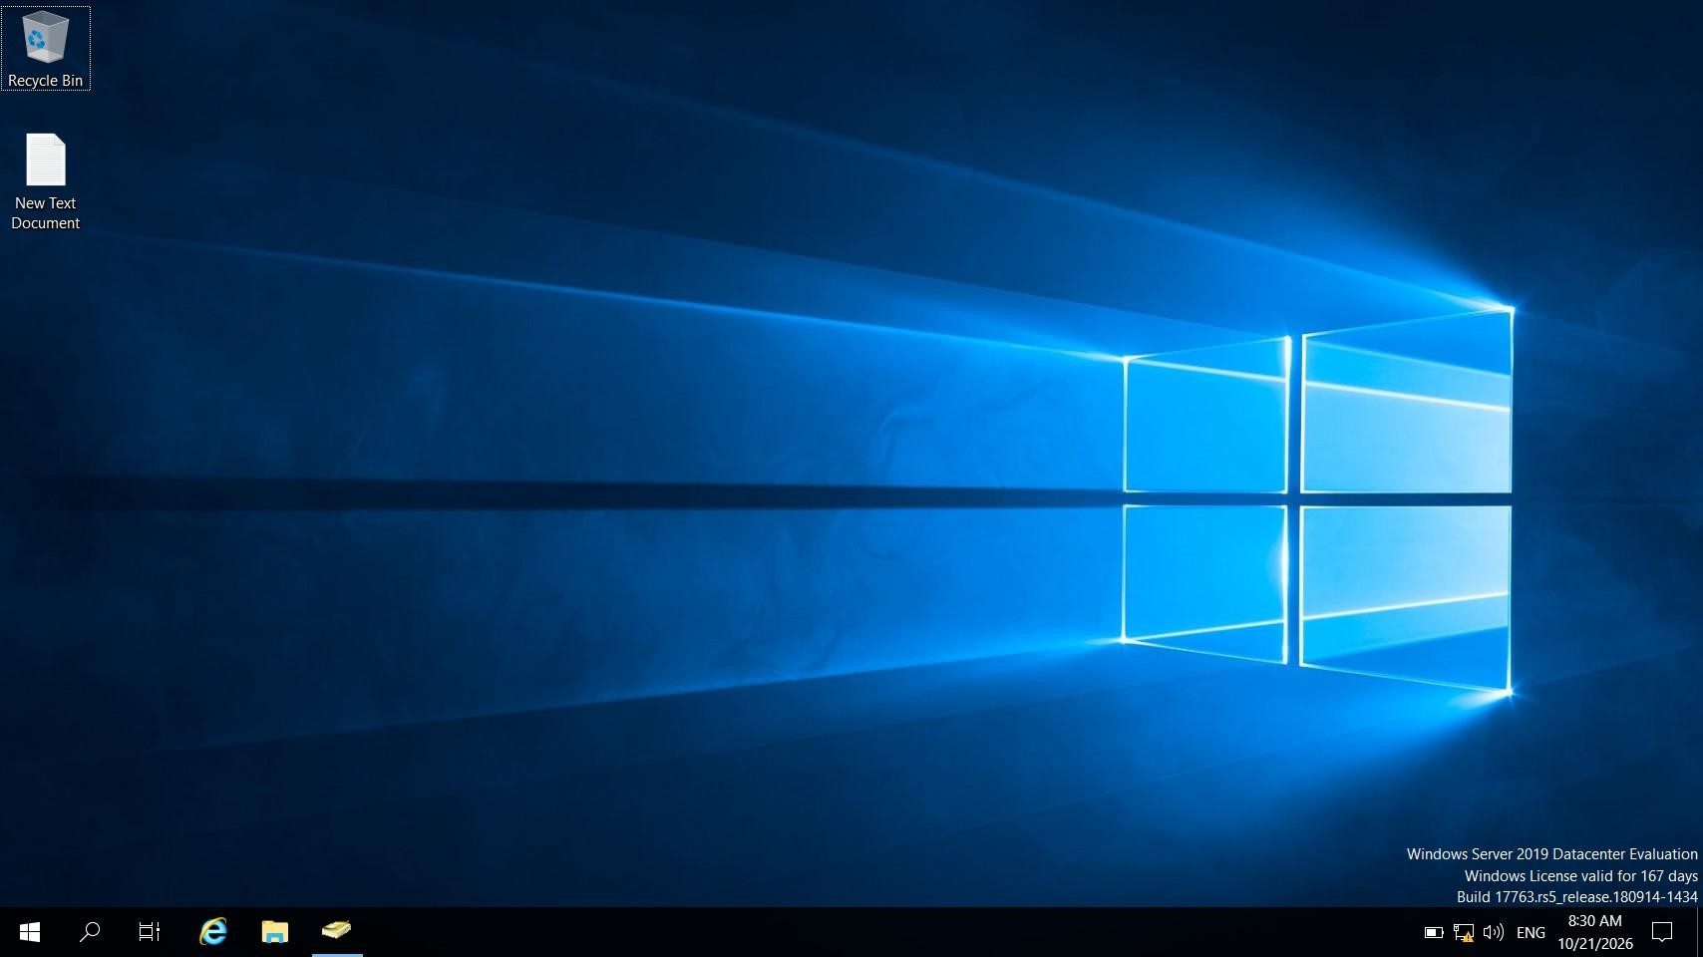
- Create a new Active Directory domain called "musicstream.local" and add two user accounts: one for 'arijit.singh' and one for 'neha.kakkar'. Capture screenshots of the AD Users and Computers console showing both accounts.
➢
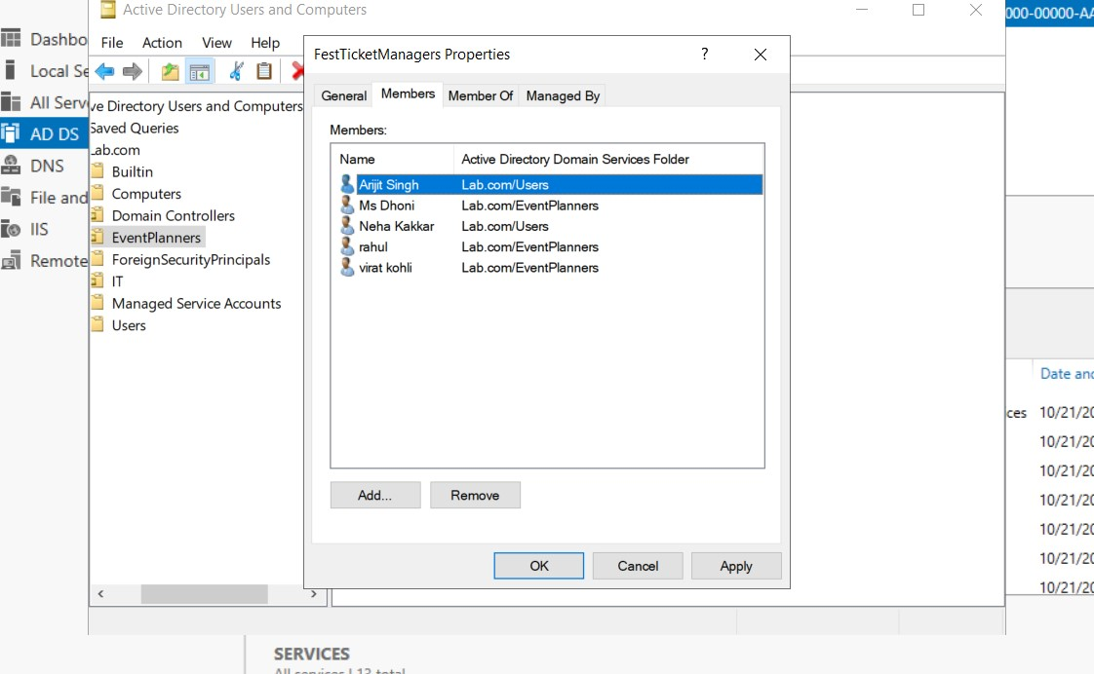
- Set up a Group Policy Object (GPO) that prevents users from accessing Control Panel, and link it to the 'Users' OU you created. Show beforeand-after screenshots of the policy in effect for one of your test users.
➢
Before screenshot
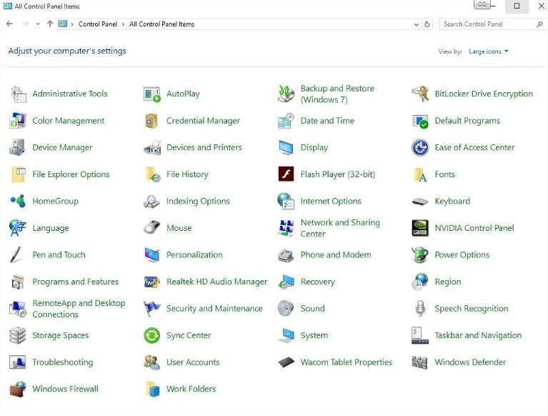

After screenshot

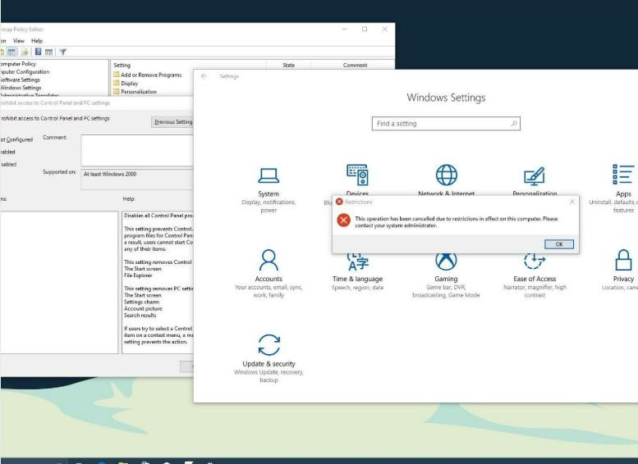

- Share a folder named 'Playlists' on your Windows Server so that only the 'arijit.singh' user can read and write files, but 'neha.kakkar' can only read. Demonstrate this by logging in as each user and attempting to create or edit a file in the shared
folder.<br><br><em><strong>Hint:</strong> Use NTFS permissions and sharing settings to control access for each user.</em> ➢
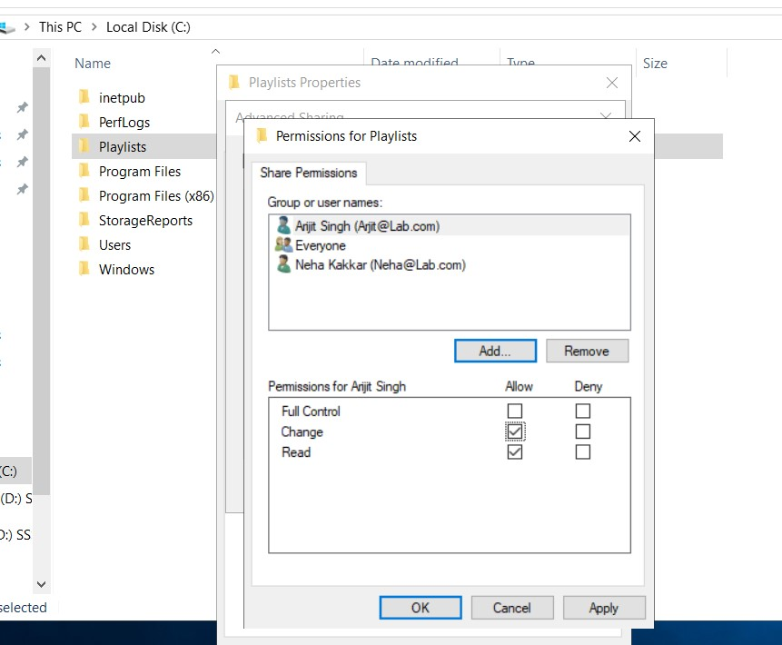

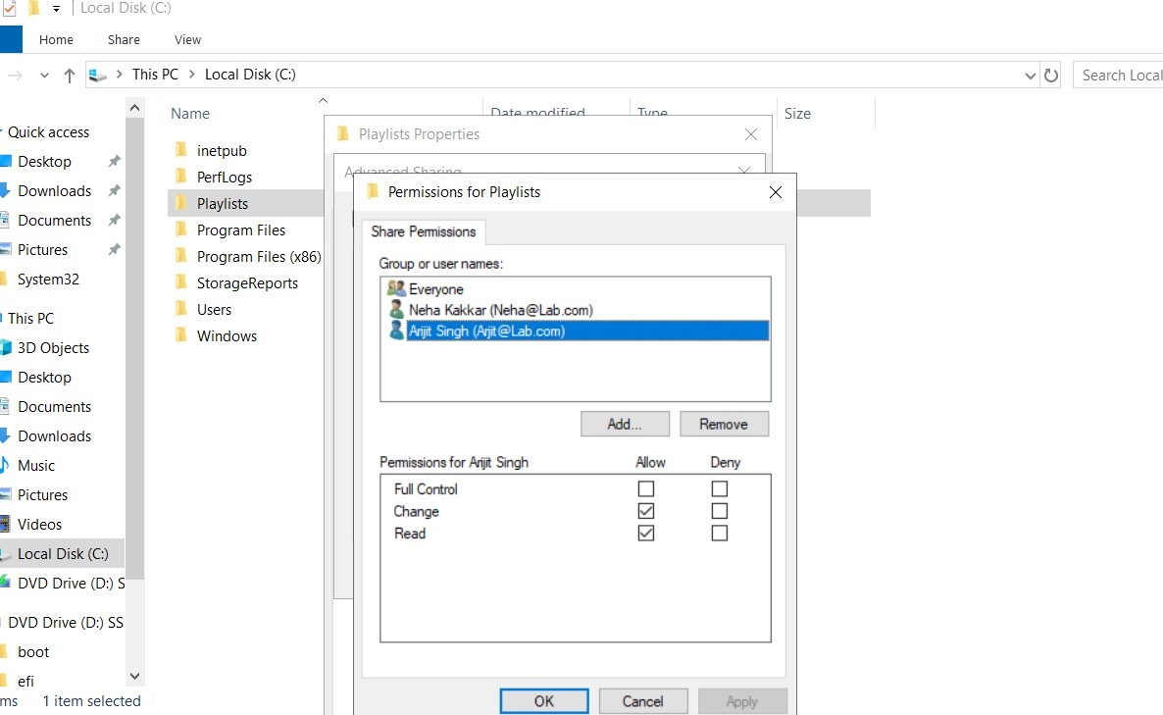

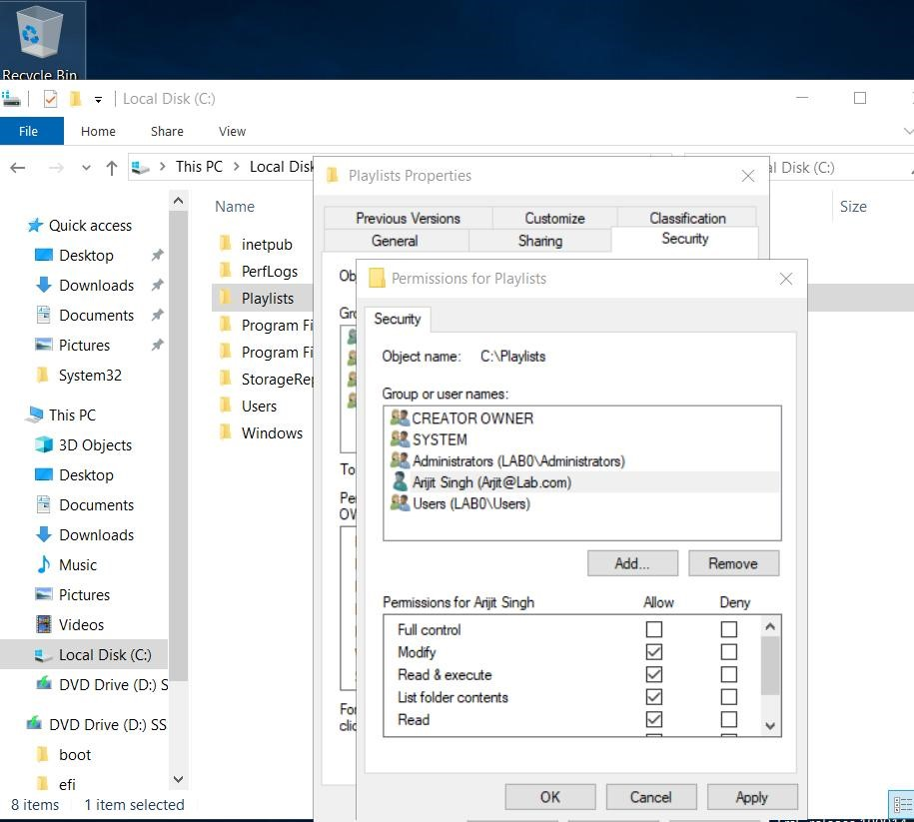

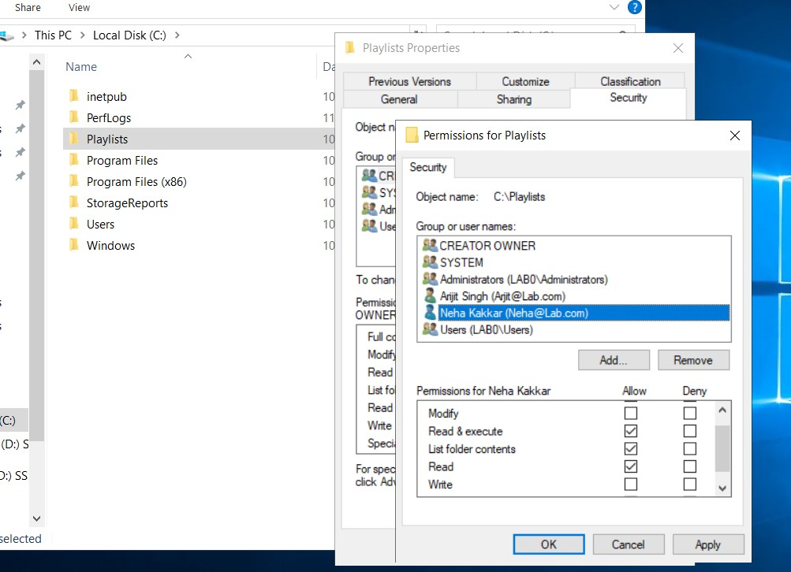

- Write a short report (1-2 pages) summarizing your domain, user, GPO, and shared folder setup. Include at least 3 screenshots and describe one challenge you faced and how you solved it.

➢

Report on Active Directory Domain and Resource Management
    - Introduction
The objective of this practical was to configure an Active Directory domain, create user accounts, apply a Group Policy Object (GPO), and set up a shared folder with different access permissions. These tasks helped me understand basic Windows Server administration and centralized user management.
    - Domain and User Setup
I configured the Active Directory domain musicstream.local using
Windows Server and the Active Directory Domain Services (AD DS) role. The domain provides centralized management of users and network resources.
I created two user accounts: arijit.singh and neha.kakkar. These accounts can be managed through the Active Directory Users and Computers (ADUC) console. Creating separate accounts helps assign permissions according to each user's requirements.
Screenshot 1: Active Directory Users and Computers showing the domain and both user accounts.
3. Group Policy Object (GPO)
I used Group Policy Management to configure a policy intended to prevent users in the selected Users organizational unit (OU) from accessing Control Panel. The policy was linked to the appropriate OU so that it could apply to the users within that OU.
This practical helped me understand how Group Policy can be used to manage user settings centrally. The policy should be verified by logging in as a test user and checking whether Control Panel access is blocked. Screenshot 2: The configured GPO and its link to the Users OU, or the Control Panel restriction shown in the test user's session.
4. Shared Folder and Permissions
I created a shared folder named Playlists on the Windows Server. I configured both sharing permissions and NTFS permissions to provide different access levels to the two users.
  - arijit.singh: Read and write access, allowing the user to create and modify files.
  - neha.kakkar: Read-only access, allowing the user to view files without creating or modifying them.
I tested the permissions by accessing the shared folder using a Windows client. The expected result was that arijit.singh could create and edit files, while neha.kakkar could read files but could not create or modify them. Screenshot 3: The shared Playlists folder with its permissions, or a test showing the different access results for the two users.
5. Challenge Faced and Solution
One challenge was configuring permissions so that one user could modify files while the other user had read-only access. Share permissions and NTFS permissions both affect access to shared files, so configuring only one of them may not produce the expected result.
I addressed this by checking the folder's Sharing and Security settings separately, assigning the required permissions to each user, and testing access with the respective user accounts.
- Conclusion
This practical improved my understanding of Active Directory, user account management, Group Policy, and shared folder security. I learned how to manage users centrally, apply policies to an organizational unit, and control access to shared resources according to user requirements.

